Catalyst Website: Structure and Copy
V1. 08/15/24

Examples:
https://www.dkbmed.com/
https://www.medlearninggroup.com/
https://vindicocme.com/
https://www.med-iq.com/

Videos? Existing Options: (to work with Jason)
https://www.catalystmeded.com/IMPACT-REEL - from Tina

OUTLINE/STRUCTURE ONLY
Homepage
- Hero Section with video / highlight reel – Jason to work on this:
  - Engaging tagline or mission statement
    - Catalyst is dedicated to improving care through cost-effective, outcomes-driven education.
  - Call-to-Action (CTA) buttons (e.g., "Learn More," "Get Started")
  - High-quality images or video background (Lou to provide examples)
- Key Features:
  - Overview of services (e.g., courses, certifications, webinars)
  - Highlights of previous work
    - MoA animations
    - Links to images/pictures from live activities
    - Patient interviews
    - Global education / translations
    - Anything else we want to feature
  - Testimonials or success stories
- Navigation Links:
  - Quick access to main sections
- (Header and Footer Needed?)
About Us
- Company Overview:
  - Mission and vision
  - History and values
- Team:
  - Profiles of key team members
  - Medical experts and educators
  - Interested in joining our team?
- Accreditations & Partnerships:
  - List of certifications
  - Partnerships with accrediting institutions, AG partners
Activities (when to list these since we do not have our own LMS):
- Activities (live and enduring):
  - Search and filter options (e.g., by category, level, duration)
  - Featured activities
- Course Details:
  - Course description
  - Learning objectives
  - Instructor information
  - Enrollment options
Resources
- Newsfeed (Blog) (show 3-5 and click for more - accordion)
  - Articles on medical education trends
  - New activity posting (mirror social media posts)
  - Expert opinions and insights
- Publications & Whitepapers:
  - Downloadable resources
  - Research and case studies
Core Collaborations
- Logos and Links (see sales slide deck for more info):
  - Accredited Providers (AK, UT, JH, IJHN)
  - Medical Societies (CMSC, IOMSN, others?)
  - Audience Generation Partners (Journals, PowerPak, FreeCME, MyCME)
  - Technology Partners (Array)

Contact Us
- Contact Form:
  - Fields for name, email, subject, and message
- Office Locations:
  - Address details
- Social Media Links:
  - Links to company’s social media profiles
Additional Sections
- Privacy Policy: vs (iubenda?)
  - Information on data protection and privacy practices
- Terms of Service:
  - Terms and conditions for using the site and services
- Accessibility:
  - Information on site accessibility features

Footer:
- Quick Links:
  - Links to main sections
  - Contact information
- Newsletter Signup:
  - Email subscription form
- Legal Links:
  - Privacy Policy
  - Terms of Service

OUTLINE/STRUCTURE + COPY
Lou
Reshma
Megan
Juliette
Homepage
- Hero Section with video / highlight reel – Jason to work on this:
  - Engaging tagline or mission statement
    - Catalyst is dedicated to improving care through cost-effective, outcomes-driven education.
  - Call-to-Action (CTA) buttons (e.g., "Learn More," "Get Started")
  - High-quality images or video background (Lou to provide examples)
    - Images found here: Images for Website - Start with image and eventually use video when ready
  - The Value of Working with Catalyst
    - Unparalleled Service
    - Strategic Instructional Design
    - Cost-effective & Outcomes-driven Education
    - Extensive Experience & Track Record of Success
    - Provide valuable outcomes data that informs internal stakeholders and defines opportunities for future education
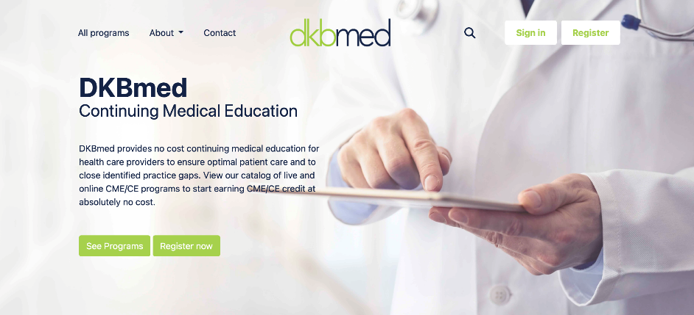 layout example
Can this be used somewhere?
- Key Features:
  - Overview of services (e.g., courses, certifications, webinars)
  - Highlights of previous work (NEED IMAGES & COPY)
    - MoA animations
      - Pompe MoA: https://vod-progressive.akamaized.net/exp=1724783824~acl=%2Fvimeo-prod-skyfire-std-us%2F01%2F2827%2F25%2F639136274%2F2928989929.mp4~hmac=e5005dd560e1918d64b17abaed6b2f294ea152a7612257b68f46bb4e77b194bf/vimeo-prod-skyfire-std-us/01/2827/25/639136274/2928989929.mp4?filename=file.mp4
      - MASH MoA: https://download-video.akamaized.net/v3-1/playback/a7c70447-edfe-4624-8b29-4fa1eb2e6281/a743ba54-0f64fe4c?__token__=st=1724769483~exp=1724783883~acl=%2Fv3-1%2Fplayback%2Fa7c70447-edfe-4624-8b29-4fa1eb2e6281%2Fa743ba54-0f64fe4c%2A~hmac=7df617f9447d777ea9a10132bdc1e6b0d02a6327329f470b2bd40f2668f8b92f&r=dXMtY2VudHJhbDE%3D
      - Hemophilia MoA: https://download-video.akamaized.net/v3-1/playback/772cb52a-0483-4ba6-8f6e-2daf3ec698a8/2150d006-d2c01502?__token__=st=1724769505~exp=1724783905~acl=%2Fv3-1%2Fplayback%2F772cb52a-0483-4ba6-8f6e-2daf3ec698a8%2F2150d006-d2c01502%2A~hmac=42ce88618cc1d598f1fcf5d44e08be462ba25d5055bb76d7a5911a5829e471a4&r=dXMtd2VzdDE%3D
      - Fabry MoA: https://download-video.akamaized.net/v3-1/playback/bf42b0a0-ccbe-40a5-be47-1f4c6dca3b86/5bae791e-6812ad73?__token__=st=1724769529~exp=1724783929~acl=%2Fv3-1%2Fplayback%2Fbf42b0a0-ccbe-40a5-be47-1f4c6dca3b86%2F5bae791e-6812ad73%2A~hmac=7f68cf1a39cf891a2cfe222094c531c9f4d96b5b2c1a2740deebfa35c296df56&r=dXMtd2VzdDE%3D
    - Links to images/pictures from live activities-need to pull from activity channels in teams
      - Images can be found here: Pictures from events
    - Patient interviews
      - Clinician Interaction Video: https://download-video.akamaized.net/v3-1/playback/c463fc28-0a32-4c67-9b21-5dbbb439b686/31482114-7541bed9?__token__=st=1724769601~exp=1724784001~acl=%2Fv3-1%2Fplayback%2Fc463fc28-0a32-4c67-9b21-5dbbb439b686%2F31482114-7541bed9%2A~hmac=47719c69c96075c07a485518eb88a7a93acb262aac6c0efc427fb66a1e553727&r=dXMtZWFzdDE%3D
      - Patient Impact Video: https://download-video.akamaized.net/v3-1/playback/c0af7a0e-3983-44fa-bd94-f02329962c3f/be9d2892-5c9e4e88?__token__=st=1724769648~exp=1724784048~acl=%2Fv3-1%2Fplayback%2Fc0af7a0e-3983-44fa-bd94-f02329962c3f%2Fbe9d2892-5c9e4e88%2A~hmac=343705118b92d4c5f43bbf861185f73c7e43299b097d85b24d6e04494c4945fe&r=dXMtZWFzdDE%3D
      - Patient Impact Video: https://vod-progressive.akamaized.net/exp=1724784084~acl=%2Fvimeo-transcode-storage-prod-us-east1-h264-1080p%2F01%2F4084%2F25%2F645421155%2F2960216738.mp4~hmac=d75b86d84041f4768d973b056e112ef7ce9b80dee7a85115411b082d2a685a6a/vimeo-transcode-storage-prod-us-east1-h264-1080p/01/4084/25/645421155/2960216738.mp4?filename=file.mp4
    - Global education / translation
      - Link to Learning Center that has translations: https://breastcancer-ce.com/resources/ (AT BOTTOM OF PAGE)
    - Anything else we want to feature
      - Patient Learning Portal: https://mydiabetesinfo.com/
      - Cadaver Anatomy Demo: https://download-video.akamaized.net/v3-1/playback/8e95dc2c-ce23-443c-95df-c9bc8ddc36bd/b6457a51-abd41d11?__token__=st=1724769909~exp=1724784309~acl=%2Fv3-1%2Fplayback%2F8e95dc2c-ce23-443c-95df-c9bc8ddc36bd%2Fb6457a51-abd41d11%2A~hmac=552bb17ed40147681b67801e94809c58e1463a544a80496d488161512de474df&r=dXMtZWFzdDE%3D
      - IMPACT Highlight Reel: https://download-video.akamaized.net/v3-1/playback/2d94196d-25a1-46cd-b630-c87972a51938/fe600339-d71b4d88?__token__=st=1724769962~exp=1724784362~acl=%2Fv3-1%2Fplayback%2F2d94196d-25a1-46cd-b630-c87972a51938%2Ffe600339-d71b4d88%2A~hmac=f3e97e1798b79ada0ea6991e77f6a3b165adb03ed1b43749d877d53ba4be872f&r=dXMtY2VudHJhbDE%3D

- Navigation Links:
  - Quick access to main sections
- (Header and Footer Needed?)
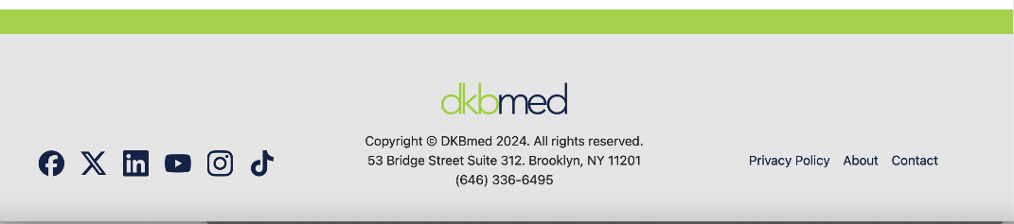
Footer example – Add ”Follow us” above social media links
About Us
- Company Overview:
  - Mission and vision
    - What we are all about... Our mission is to accelerate learning throughout the continuum of care by providing health care professionals and patients, around the world, with education that empowers change.
    - How we accelerate learning... Our educational interventions speed the translation of the latest clinical data into everyday practice through strategic instructional design methods and incorporation of adult learning principles.
    - How we provide value... We provide value by developing cost-effective, outcomes-driven education dedicated to improving learners’ knowledge, skills, attitudes, and behaviors—ultimately leading to better patient care.
 Can we use the branding in this section?

- Team:
Meet Team Catalyst
- Catalyst’s core team members boast a collective 100+ years of independent medical education experience!!
- Louis Settembrino, CHCP, Founder and CEO
  - 18 years’ experience in Independent Medical Education (IME) across 30+ disease areas
  - Expertise in strategy, instructional design, and outcomes assessment
  - Long term relationships with educational partners, institutions, and faculty experts
- Reshma Desai Carter, PharmD, COO
  - 22 years’ experience in IME across 50+ disease areas
  - Expertise in outcomes measurement methodology, assessment tools, analysis, reporting, and publications
  - Experience across all aspects of IME including instructional design, clinical development, accreditation standards, and outcomes
- Jessica F Marshall, PhD, Vice President, Medical Strategy
  - 11 years’ experience in IME across 50+ disease areas
  - Strong background in clinical research including literature review, gap analysis, content development
  - History of managing 200+ needs assessments a year
- Cathy Zehr, Director, Project Management
  - 30 years’ experience in IME
  - Strong background in program management, meeting planning, marketing, faculty communication, and graphic design
  - History of managing 50+ activities a year
- Juliette Reinsel, PharmD, Manager, Educational Grants
  - 5+ years clinical experience in coordinating therapeutic care within 1000+ bed academic teaching hospital, corresponding with providers, nurses, and social workers
  - Expertise in conducting root cause analysis to determine underlying gaps in care and knowledge ex. "fix-it pharmacist"
  - Clinical perspective of therapeutic landscapes and ability to identify educational gaps
- Alexandra Marsillo, PhD, Director, Medical and Scientific Services
  - 6 years of diverse experience in IME, with a specialized focus on oncology
  - Demonstrated success in directing grant and education material development to achieve impactful outcomes, aligning stakeholder objectives with learners' educational needs
  - Background in clinical research and higher education, emphasizing scientific understanding and effective communication
- Megan Clewell, Manager, Projects and Marketing
  - 12 years of graphic design experience
  - Strong background in social media, marketing, and project management
  - 7 years of life science experience
- Interested in joining our team? - button for email (what email?)

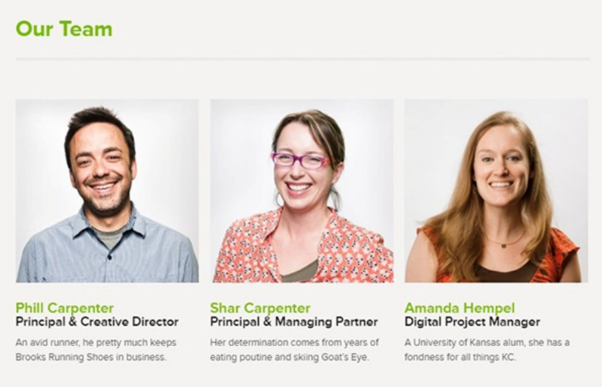 Example of layout
Team photos found here: Team Pictures - where can we find these? - Lou?
- Accreditations & Partnerships:
  - Accredited Providers (AK, UT, JH, IJHN)
  - List of certifications
  - Partnerships with accrediting institutions, AG partners
Activities (when to list these since we do not have our own LMS):
- Activities (live and enduring):
  - Search and filter options (e.g., by category, level, duration)
  - Featured activities
    - Learning Centers
      - Hemophilia: https://hemophilia-ce.com
      - Follicular Lymphoma: https://fl-cme.com/
      - The IMPACT Initiative: https://impact-smd.com/
      - Pompe Disease: https://pompecme.com/
      - Distributed nationally or globally, via a journal package, with the option to offer content and resources in various languages, as appropriate (see resources page for examples).
    - Pharmacy Education
      - https://www.powerpak.com/course/preamble/123776
      - We have a successful partnership with the University of Tennessee College of Pharmacy to provide
- Course Details:
  - Course description
  - Learning objectives
  - Instructor information
  - Enrollment options
Resources
- Newsfeed (Blog) (show 3-5 and click for more - accordion)
  - Articles on medical education trends
  - New activity posting (mirror social media posts)
  - Expert opinions and insights
- Publications & Whitepapers:
  - Downloadable resources
  - Research and case studies
Core Collaborations
- Logos and Links:
  - Accredited Providers (AK, UT, JH, IJHN)
  - Medical Societies (CMSC, IOMSN, others?)
  - Audience Generation Partners (Journals, PowerPak, FreeCME, MyCME)
  - Technology Partners (Array)
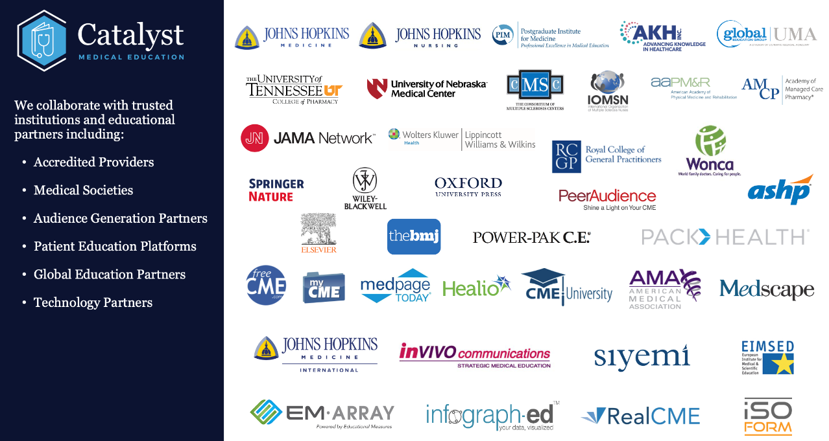
(Our largest ones, if we need to scale back, would probably be Johns Hopkins, AKH, and University of Tennessee College of Pharmacy.)

Contact Us
- Contact Form:
  - Fields for name, email, subject, and message
- Office Locations:
  - 55 Madison Ave, Suite 400, Morristown, NJ 07960
  - PO Box 1323, Madison NJ 07940
- Social Media Links:
  - LinkedIn – https://www.linkedin.com/company/catalystmeded
  - X – https://x.com/CatalystMedEd
  - Facebook – https://www.facebook.com/profile.php?id=61565082170491
  - Instagram – https://www.instagram.com/catalystmedicaleducation/
Additional Sections
- Privacy Policy: vs (iubenda?)
  - Information on data protection and privacy practices
- Terms of Service:
  - Terms and conditions for using the site and services
- Accessibility:
  - Information on site accessibility features

Footer:
- Quick Links:
  - Links to main sections
  - Contact information
- Newsletter Signup:
  - Email subscription form
- Legal Links:
  - Privacy Policy
  - Terms of Service

